**Step by step to GitHub pages**

**Introduction to GitHub Pages**

GitHub Pages is a free hosting service offered by GitHub that allows you to publish static websites directly from a GitHub repository.

**It’s perfect for hosting:**

* Personal portfolios
* Project documentation
* Resume sites
* HTML/CSS/JavaScript apps
* Static landing pages

**Key Features:**

* Free to use
* No server setup required
* Directly integrates with your GitHub repository
* Supports custom domains
* Automatically updates your site when you push changes to your repository

***Prerequisites*:**

* A GitHub account: Sign up here if you don't have one.
* Basic knowledge of Git or GitHub interface.
* A static project folder (with files like index.html, style.css, script.js).

***Step 1: Create a New Repository***

1. Go to <https://github.com>.
2. Click **+** (top-right) → **New repository**.

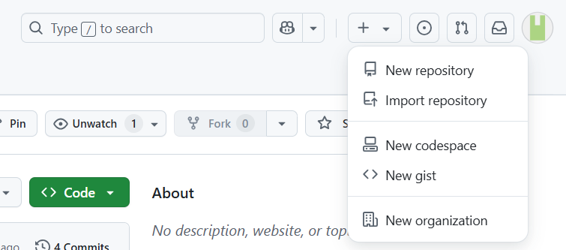



1. Give it a name (e.g., simple_html_pages).

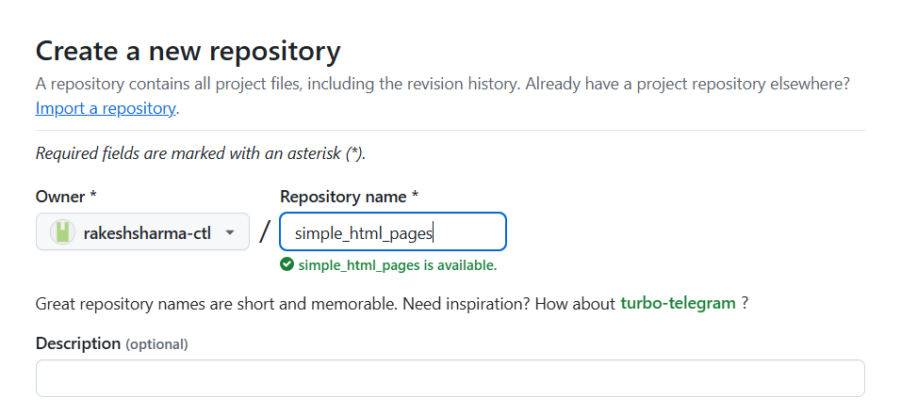



1. Select: Public (*Initialize this repository with a README)*

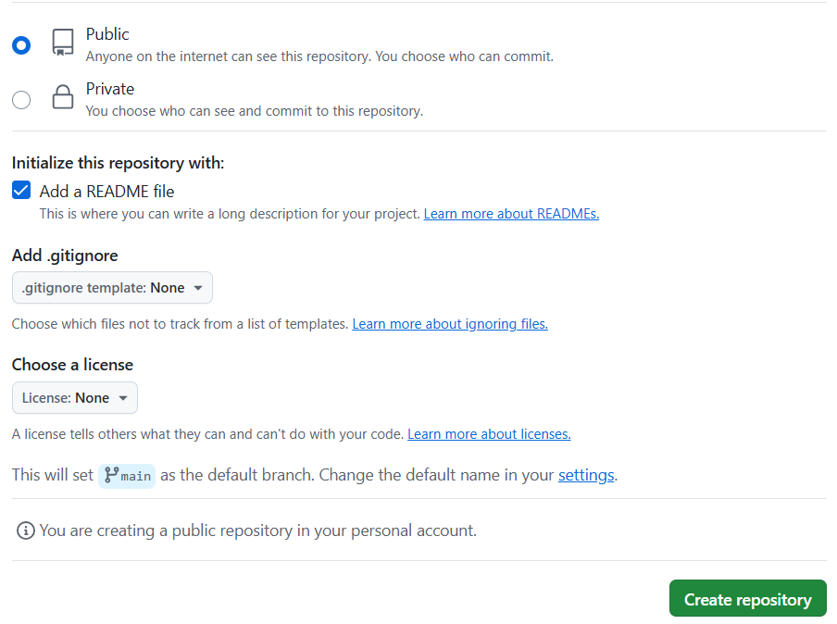



1. Click **Create repository**.

**Step 2: Upload Your Files**

1. **Option A: Use GitHub Web UI**
2. Open the repository.
3. Click **"Add file" → "Upload files"**.

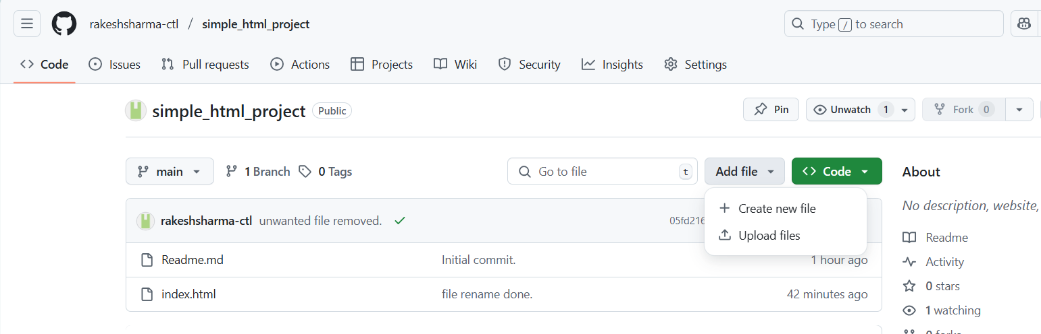



1. Drag and drop your index.html, style.css, etc.
2. Click **Commit changes**.

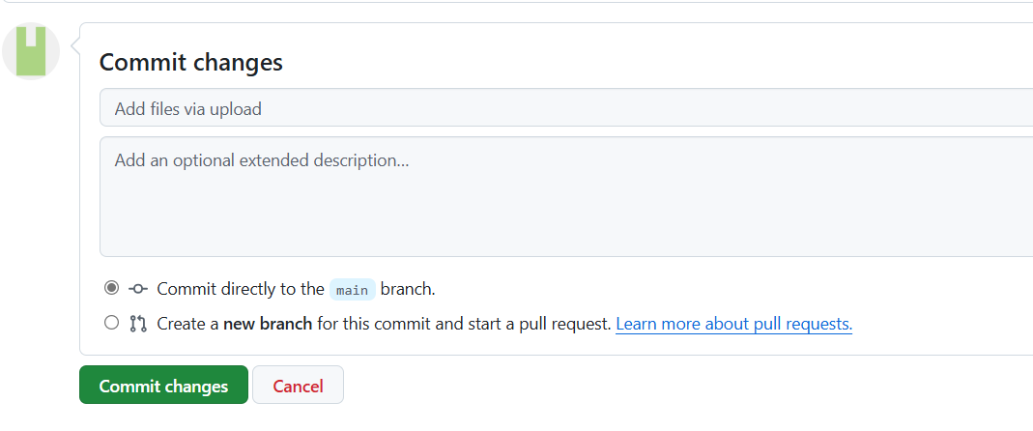

If you want to do it from your terminal, then follow the code below.

1. # On your computer terminal

2. git clone https://github.com/your-username/simple_html_pages.git

3. cd simple_html_pages

4. # Copy your files into this folder

5. git add .

6. git commit -m "Add static site files"

7. git push origin main

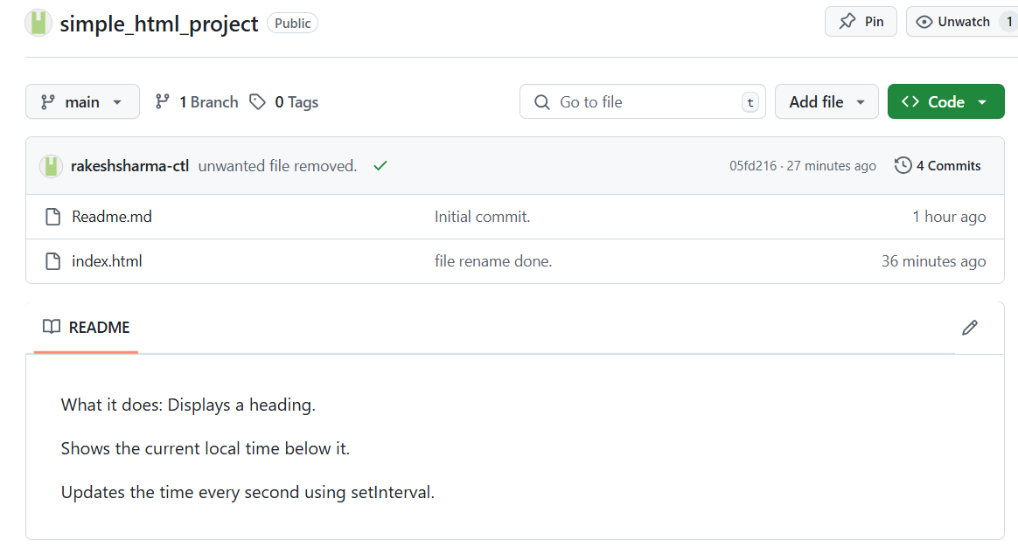

Files added.

**Step 3: Enable GitHub Pages**

1. Go to your repository on GitHub.
2. Click **Settings** (⚙️ top menu).

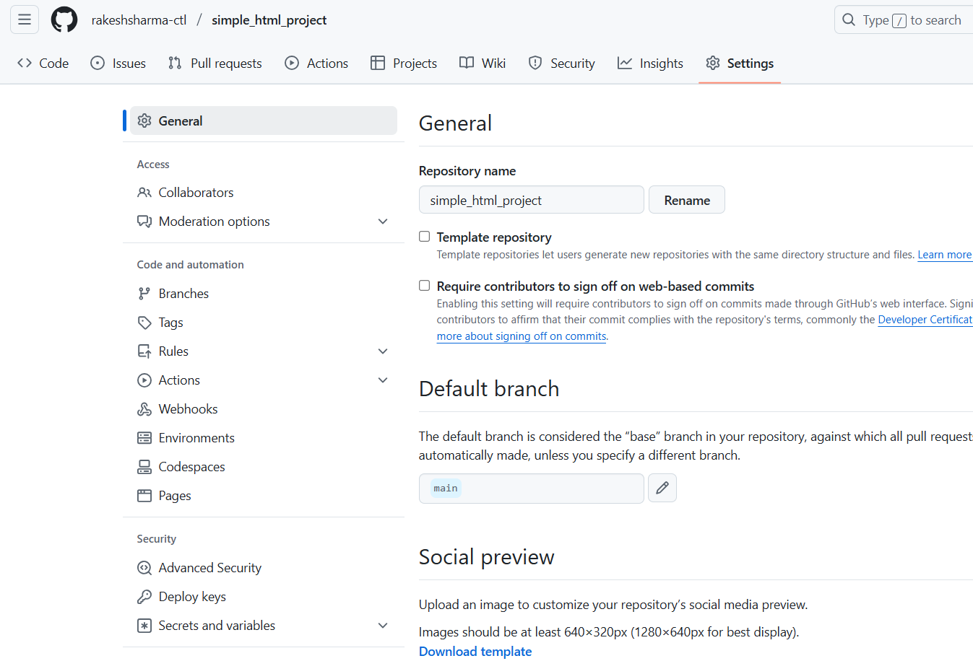



1. In the left sidebar, go to **"Pages"**.
2. Under **"Build and deployment"**, set:

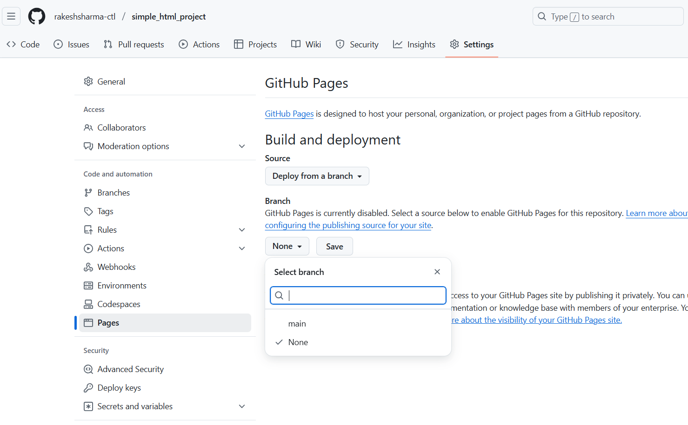



1. **Source**: Deploy from a branch
2. **Branch**: main
3. **Folder**: / (root)

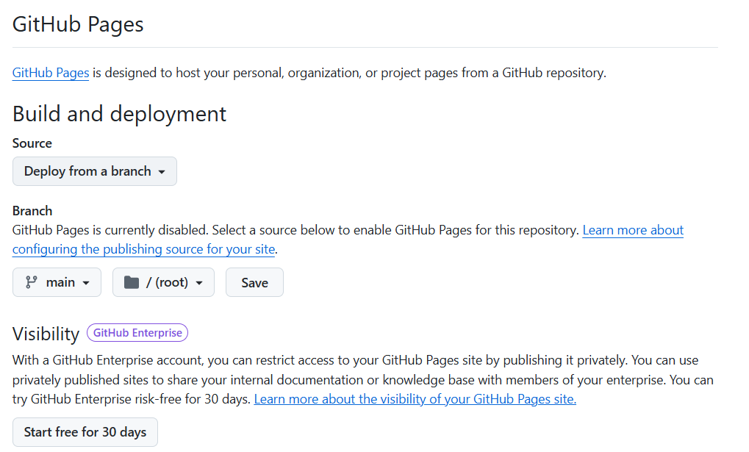



1. Click **Save**.

**Done! Your site will be live at:**

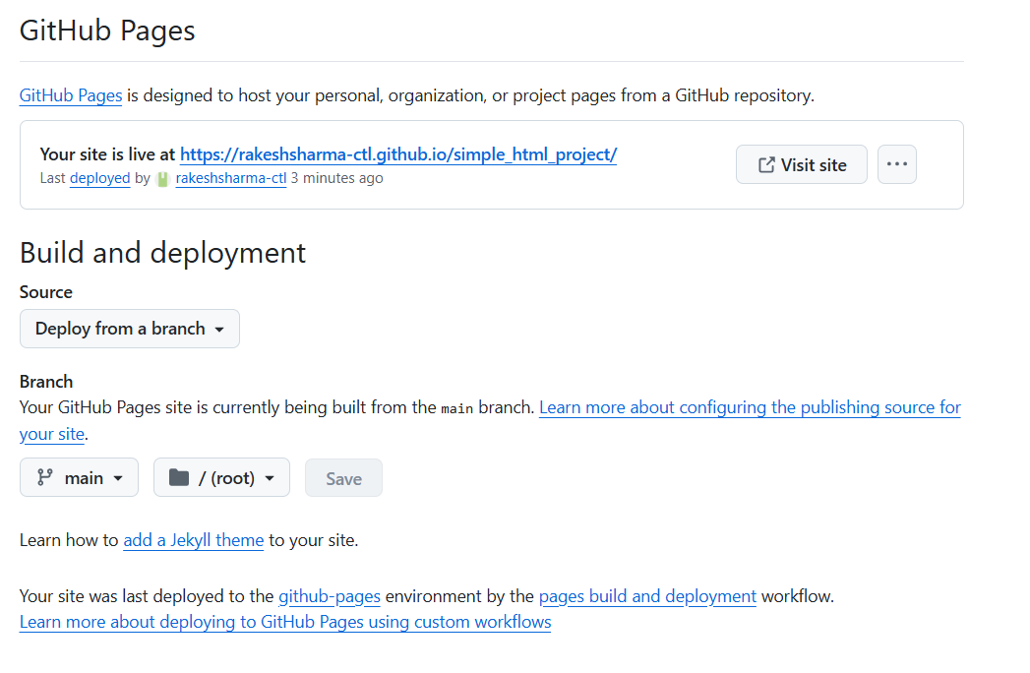



sample url : https://your-username.github.io/repository-name/

